SIMPLILEARN Full Stack Developer - MERN Stack Masters Program
Course – 5 Develop a Reliable Backend with Node and Express
Assessment – Screenshots for Project Implementation
Student Name : Vedaang Sharma

- GET http://localhost:3000/api/stocks/all?exchange=US&limit=100

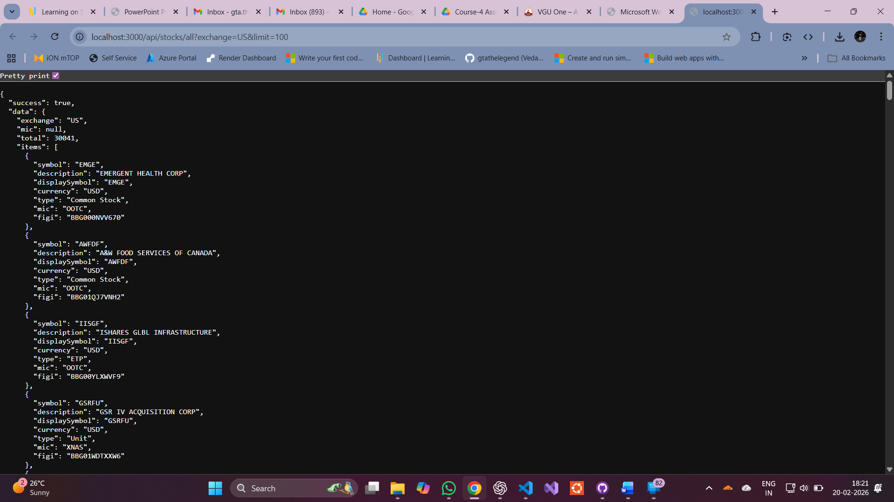

- GET http://localhost:3000/api/market/trending

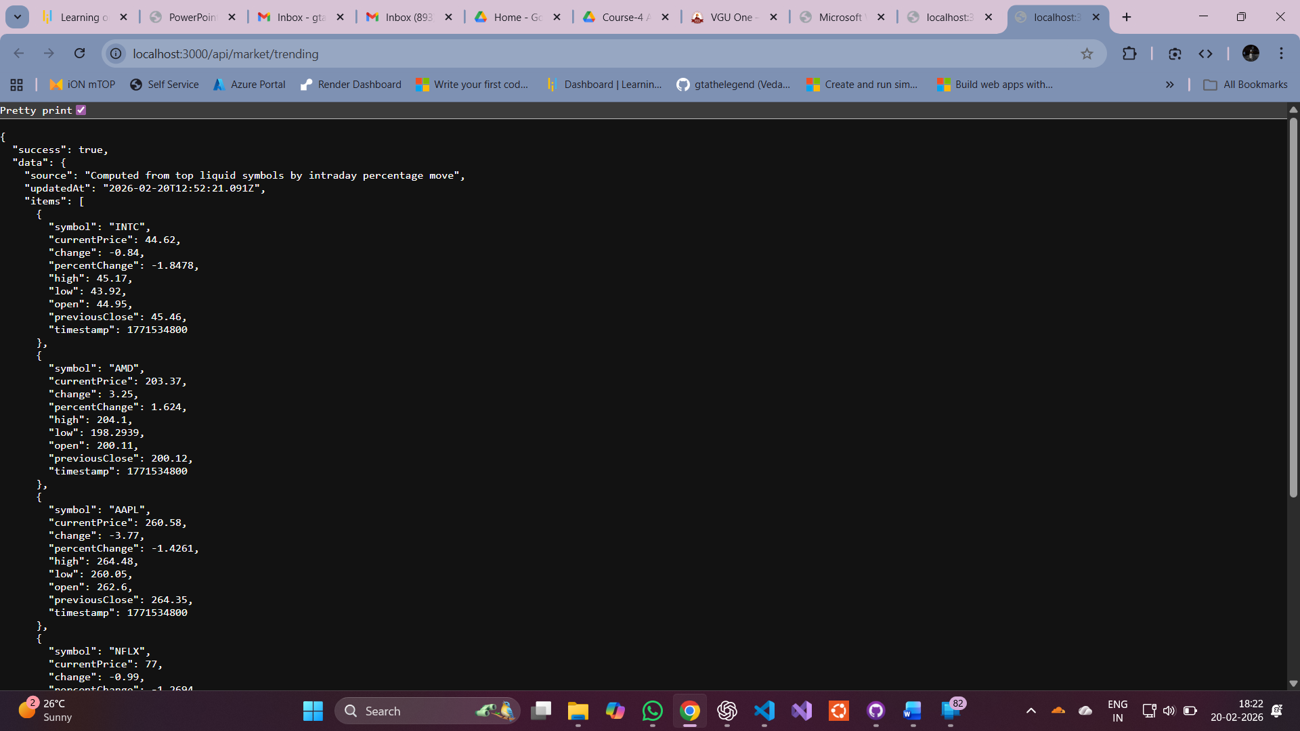

- GET http://localhost:3000/api/stocks/all
